Procedures and Functions

Q1: Create a stored procedure called uspcountriesasia to list out all the countries with continentid equal to 1, in alphabetical order

create procedure uspCountriesAsia

as

begin

select countryName from tblCountry where ContinentID=1 order by CountryName asc;

end

exec uspCountriesAsia;

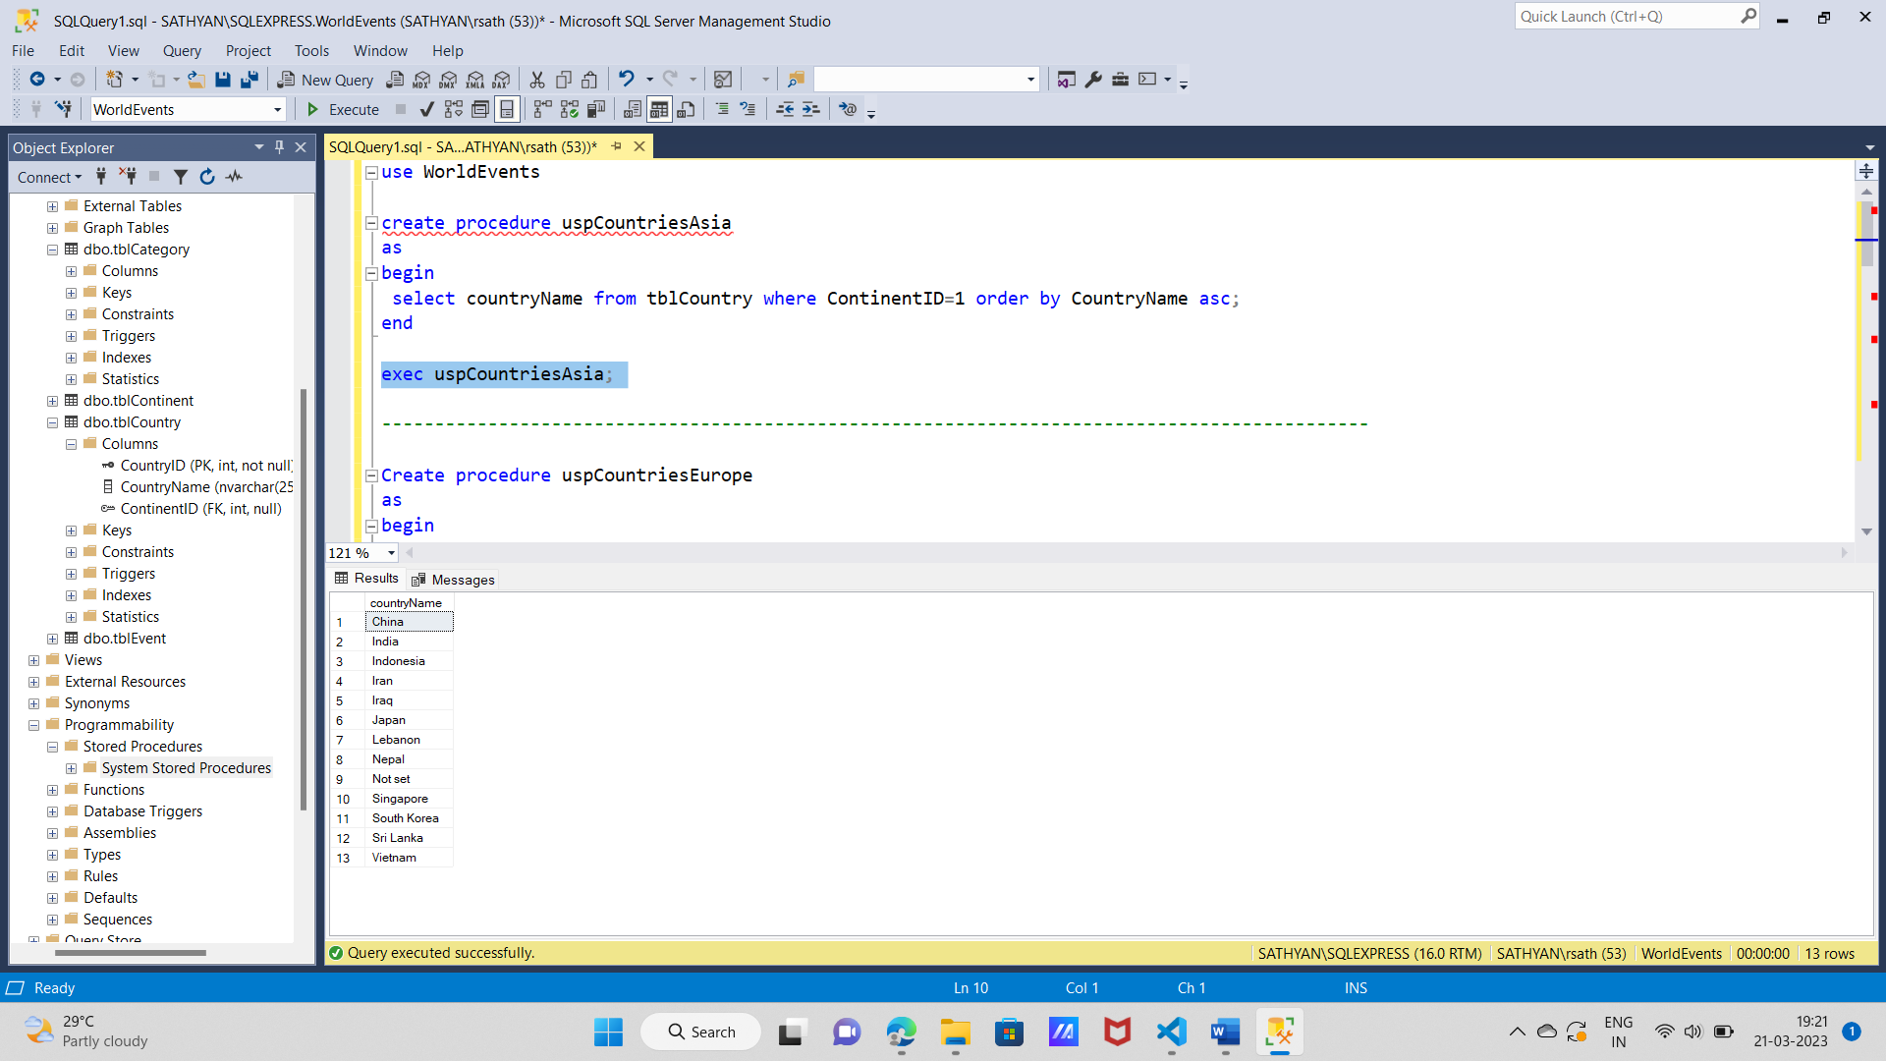

Q2:Modify the text of your query to create a different procedure called uspcountrieseurope which lists all the countries in continent id number 3

Create procedure uspCountriesEurope

as

begin

select countryName from tblCountry where ContinentID=3;

end

exec uspCountriesEurope;

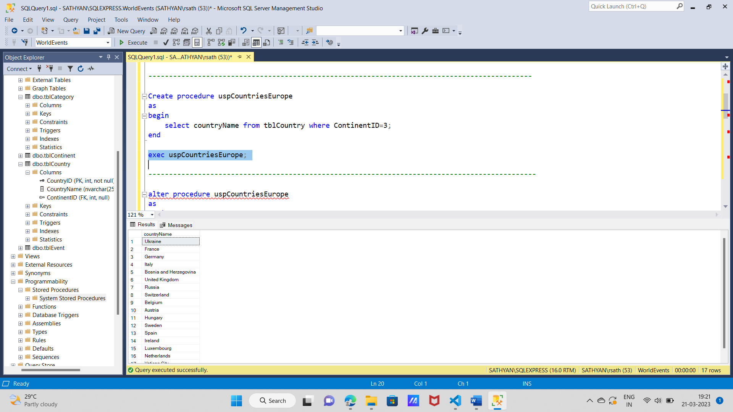

Q3: change the procedure in Q2 so that it list out the countryid also

alter procedure uspCountriesEurope

as

begin

select CountryID, countryName from tblCountry where ContinentID=3;

end

exec uspCountriesEurope;

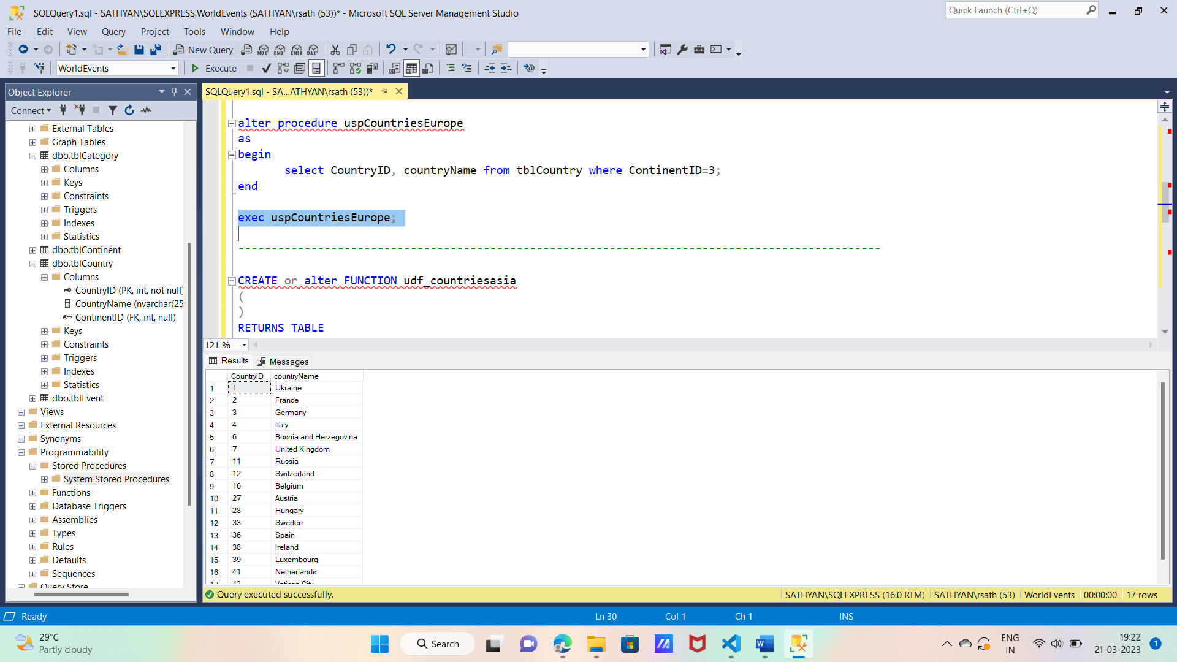

Q4:create a function for Q1

CREATE or alter FUNCTION udf_countriesasia

(

)

RETURNS TABLE

AS

RETURN

(

-- Add the SELECT statement with parameter references here

SELECT CountryName from tblcountry where continentId=1

)

select * from udf_countriesasia() order by CountryName;

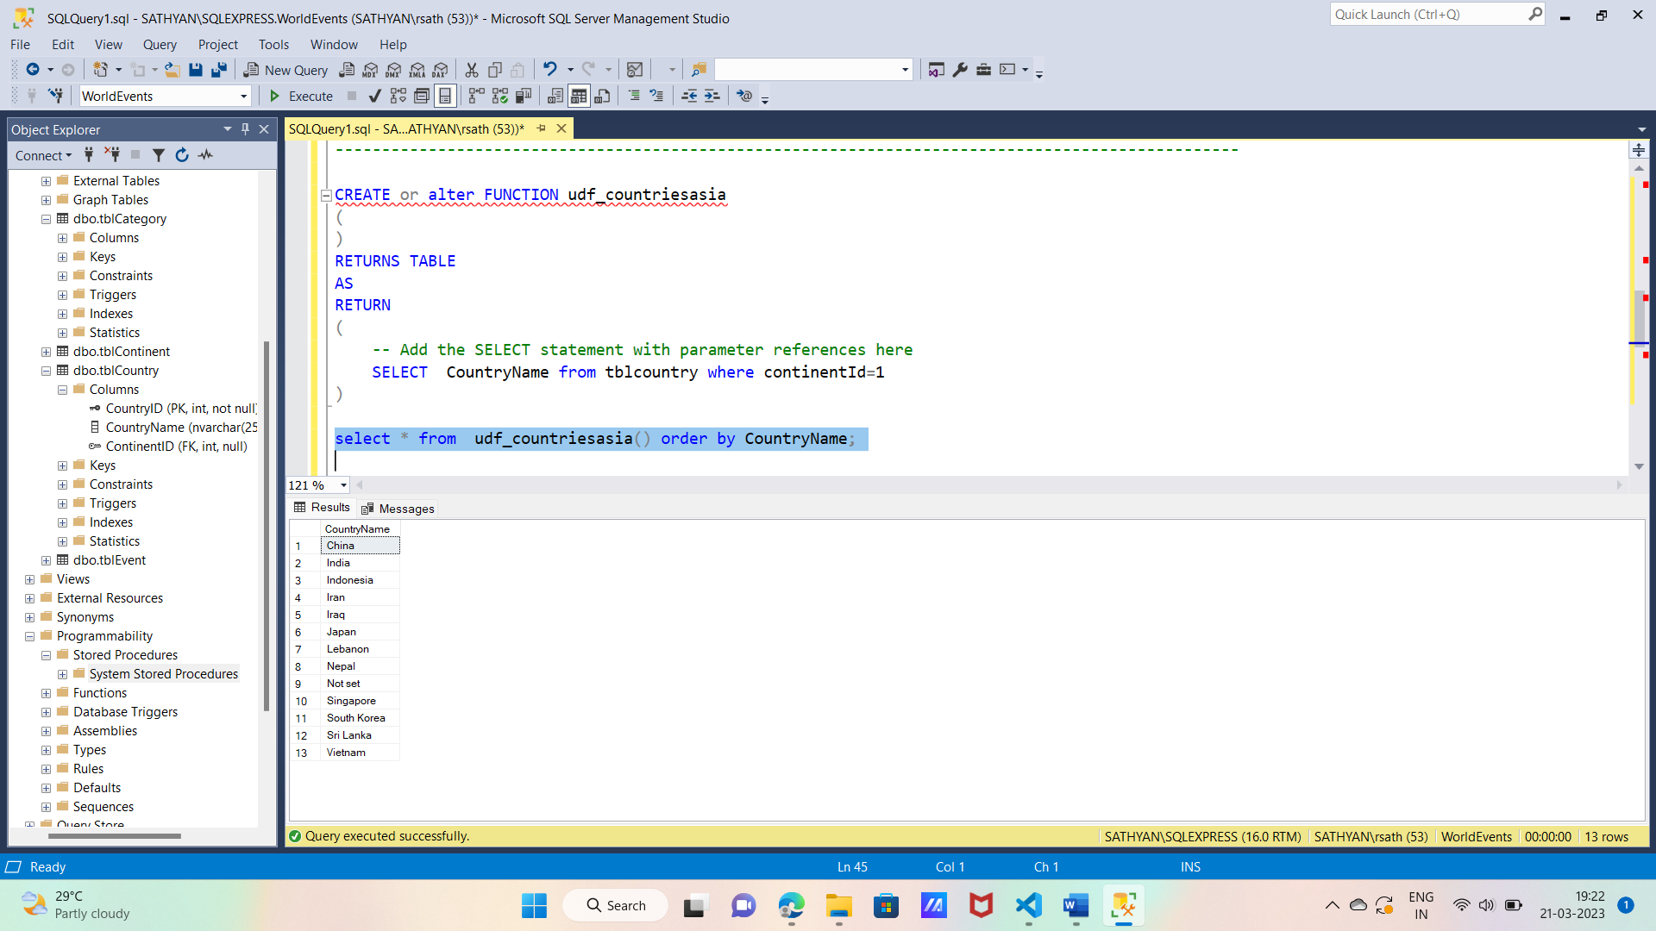

Q5:Convert Q2 into a function

CREATE or alter function udf_countries_europe()

-- Add the parameters for the stored procedure here

returns table

as

return

(

-- Insert statements for procedure here

SELECT CountryName,countryid from tblcountry where continentId=3

)

select * from udf_countries_europe();

